1.Get me the IP address of a particular domain (guvi.in). How do I find my CPU/memory usage of my server?. Test the connectivity between 2 nodes?



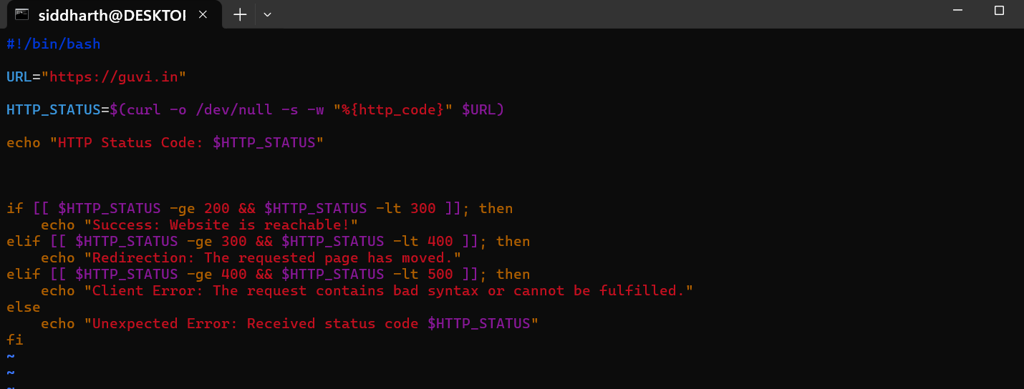



Given a file, replace all occurrence of the word "give" with "learning" from 5th line till the end in only those lines that contain the word "welcome"

